CHAIRMAN  CARL BORN  07534 471 214  36 MacDonald Parade  Whitstable  CT5 4SL | SECRETARY  CLAIRE CLARK  07740 619 918  43 Ford Close Herne Bay  CT6 8AN | TREASURER  JON WARDEN  07710 989 975  21 Dering Road Herne Bay  CT6 5RD | Welfare Officer  ANDREW RAINSBURY  07930 483 881
HERNE BAY YOUTH GIRLS/LADIES 6-A-SIDE TOURNAMENT – SUNDAY 6th JUNE 2020
HERNE BAY YOUTH 6-A-SIDE TOURNAMENT – SUNDAY 7th JUNE 2020
SUPPORTING THE LADY MAYORESS’ CHARITY
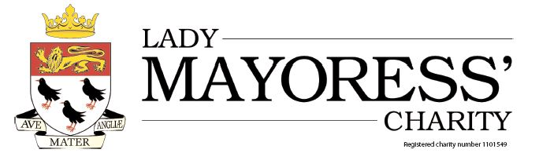
Dear Sir/Madam
Following on from our biggest and most successful tournament last year, we would like to invite your Club to take part in Herne Bay Youth FC’s, 6 a-side Football Tournament. The Tournament will take place at the University of Kent, Canterbury Campus, Saturday 6th/Sunday 7th June 2020. Herne Bay Youth FC will be making a donation to the Lady Mayoress’ Charity from the entry fees received.
The Tournament will be open to all age groups from Under 8 Girls to Ladies (Sat 6th June) and Under 6 to Under 16’s (Sun 7th June). Please note age groups at the start of the 2019-20 Season apply. Under 6s-8s will be 5 aside and Non-Competitive. All players up to the age of U8’s inclusive, will receive a participation medal.
Each of these teams will be allowed a maximum of 8 registered players. The entry fee for this Tournament is £30.00 per team.
CLOSING DATE FOR ENTRIES IS 17TH MAY 2020
The returned entry application forms will be dealt with ‘first come first served’ basis, as the number of places is limited. Last year the Tournament was over-subscribed so please complete your entry forms early to avoid disappointment.
Nearer the date of the event, all participating teams will be sent full details regarding the structure of the tournament, the start times and the rules that will be applied. Please note that some teams will maybe playing on the 3G which will be confirmed when you are sent further details for the day.
Herne Bay Youth FC is looking forward to receiving your application, and if you would like further details or have any questions please contact us at (hbytournament@gmail.com)
Yours Sincerely,
C born
Club Chairman
HERNE BAY YOUTH GIRLS/LADIES 6-A-SIDE TOURNAMENT – SUNDAY 6th JUNE 2020
HERNE BAY YOUTH 6-A-SIDE TOURNAMENT – SUNDAY 7th JUNE 2020
CLUB NAME
KCFA AFFILIATION CODE
SECRETARY’S NAME
SECRETARY’S ADDRESS
SECRETARY’S PHONE No. |  | MOBILE
SECRETARY’S EMAIL

Please Enter No. of Teams at Each Age in the table below
U6 | U7 | U8 | U9 | U10 | U11 | U12 | U13 | U14 | U15 | U16 | LADIES

Please Enter Team Managers Details below
Team Name | Manager’s  Name | Contact Phone Number | Contact Email  Address
U
U
U
U
U
U
U
U
U
U
TOTAL NUMBER OF TEAMS ENTERED
TOTAL ENTRY FEE @ £30.00 per team
Please return entry form to:
hbytournament@gmail.com
BACS payment to be made to NatWest,
Account No: 54086094, Sort Code: 60-10-37
Please use Club/Team name as reference.
Final Date for Entries: SUNDAY 17th May 2020
Entries will be confirmed when accepted

