KGLFL – Grants Programme

2018/19 Season

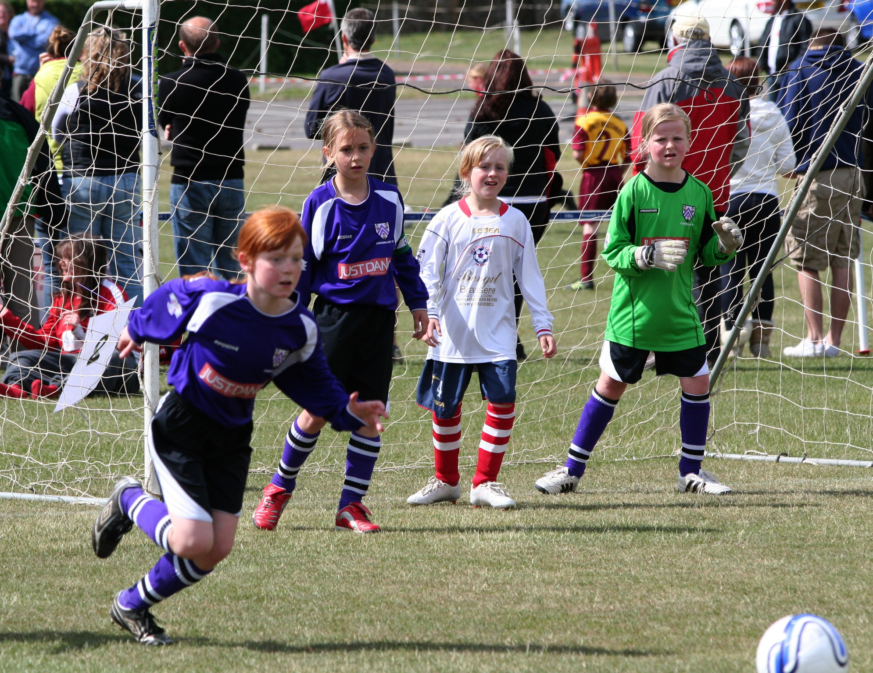

2018/19 Season – Funding
The Kent Girls and Ladies Football League have traditionally supported the training of girl’s football coaches within our member clubs with the issue of bursaries and grants for FA Level 1 Coaching and Youth Module 1 courses.

The League committee have committed to continuing this programme and also enhancing the scheme to include Referees courses.

Courses Covered by the Programme
FA Level 1 Coaching Courses (KGLFL will fund 50% of the cost)
FA Basic referees Course ((KGLFL will fund 50% of the cost)
Clubs Covered by the scheme
Any Charter Standard Club that has registered a team with the KGLFL in the Season when the application is made.

Restrictions on Applicants
Applications for Grants under this scheme are restricted as follows :

- Time Frame: There is now no time restriction for applicatiions
- Financial Limits: The League will place a cap on the funds available for the scheme. Applicants will be dealt with on a first come first served basis until the funding limit has been reached.
- Individual Limits: One application per individual during each season.
- Age Groups: Applicants applying for Coaching course grants must be currently coaching Girls Football at a Club who are members of the KGLFL in the season when the application is made.
- Referees: Referees are required to register on the KGLFL Referee Officer’s central list of referees.

Application Process
- Clubs / Individuals should book and pay for their own courses in advance.
- Grant Request Form should be filled in and returned to the League after the course is completed.
- League officials will confirm applications are correct and that the course has been completed.
- Applications will be passed to the League Treasurer to issue funds to the Club.

Please return all application forms to :
Mike Hanaway, League Secretary, 69 Birchwood Avenue, Sidcup, Kent, DA14 4JZ
OR by scanning and emailing the signed application form to MIKEKGLFL@hotmail.co.uk

If you are unsure about qualification for a grant, please contact the League Secretary in advance of your application.

KGLFL – Grant Application Form

